Use Case: Trade and Economy

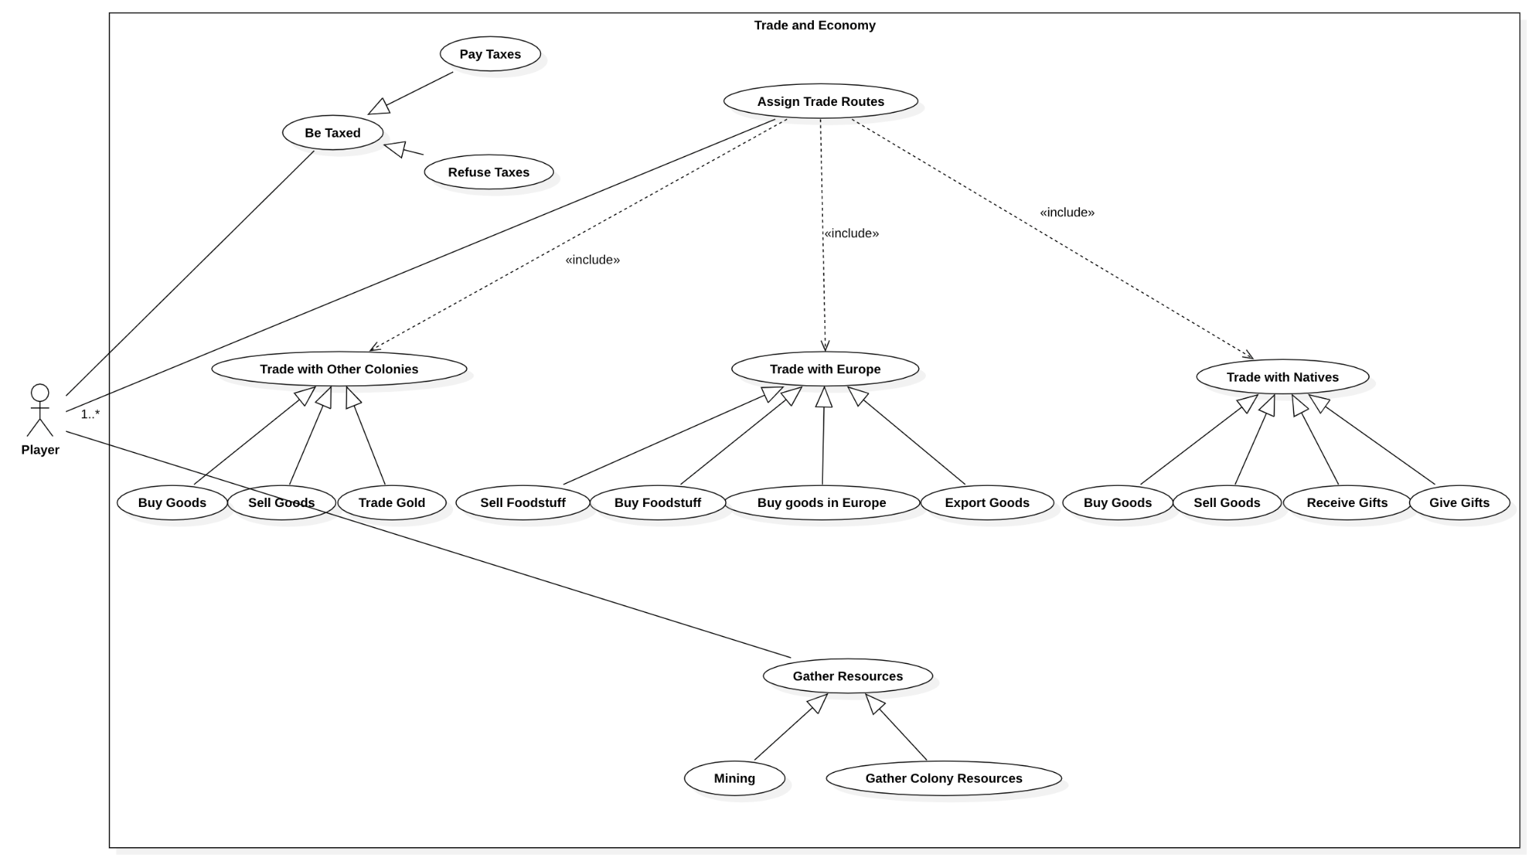

In terms of actors, the Use Case diagram illustrating Trade and Economy has the actor Player. This actor, which represents either a human or a non-human player, may perform all the actions stated in the diagram and some of the actions in question might involve more than one Player actor.

The actions that may be performed by the player actor are the following: Be Taxed, Assign Trade Routes and Gather Resources.

# Be Taxed

This Use Case represents the abstract case in which the primary actor (Player) is taxed. This Use Case has two extensions: Pay Taxes and Refuse Taxes. In the extension Pay Taxes, the primary actor (Player) accepts the appointed taxes and pays the according amount. In the extension Refuse Taxes, the primary actor (Player) refuses the payment of the due taxes, which may, for instance, lead to a boycott of goods.

# Assign Trade Routes

In this Use Case the primary actor (Player) may assign Routes in order to establish trade, therefore, this case is included in the actions of Trading with Other Colonies, Trading with Europe and Trading with Natives. This action might be performed by one or more Players, as the trading relationships can be established with other Players, may they be human or not.

# Gather Resources

This Use Case represents the abstract case in which the primary actor (Player) gathers resources that will then be traded through the established trade routes. This Use Case has 2 extensions: Mining and Gather Colony Resources. In the extension Mining, the primary actor (Player) gathers mining resources that will then be traded. In the extension Gather Colony Resources, the primary actor (Player) gathers raw materials that may then be traded as is, or traded after being used to produce other items, such as luxury goods, for example.

Beatriz de Caiola Machado, 62551